**WEEK- 5**

**MICROSERVICES**

**Creating Microservices for account and loan**

**MY CODE:**

AccountController.java

package com.cognizant.account.controller;

import org.springframework.web.bind.annotation.*;

import java.util.Map;

@RestController

@RequestMapping("/accounts")

public class AccountController {

@GetMapping("/{number}")

public Map<String, Object> getAccountDetails(@PathVariable String number) {

return Map.of(

"number", number,

"type", "savings",

"balance", 234343

);

}

}

**OUTPUT:**

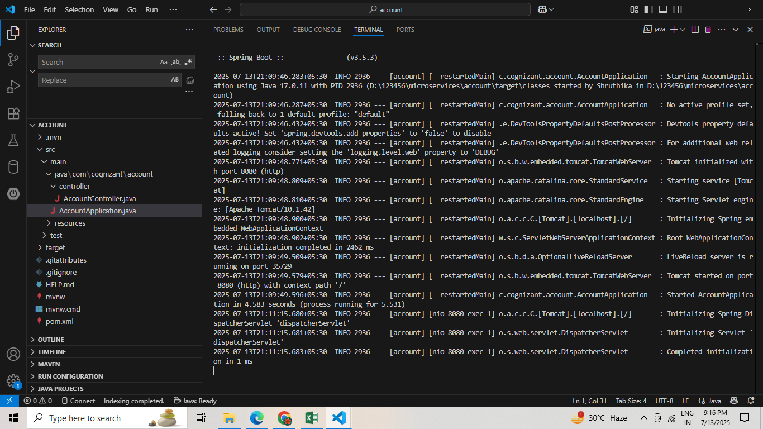

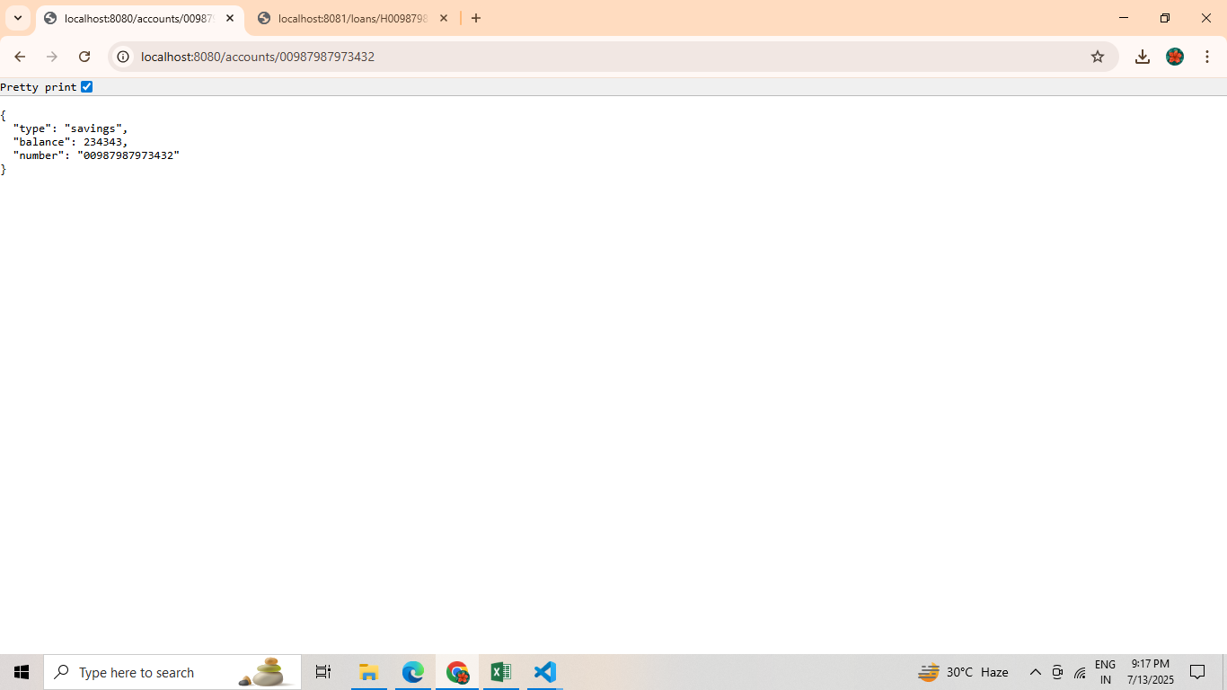

**LoanController.java**

package com.cognizant.loan.controller;

import org.springframework.web.bind.annotation.*;

import java.util.Map;

@RestController

@RequestMapping("/loans")

public class LoanController {

@GetMapping("/{number}")

public Map<String, Object> getLoanDetails(@PathVariable String number) {

return Map.of(

"number", number,

"type", "car",

"loan", 400000,

"emi", 3258,

"tenure", 18

);

}

}

**OUTPUT:**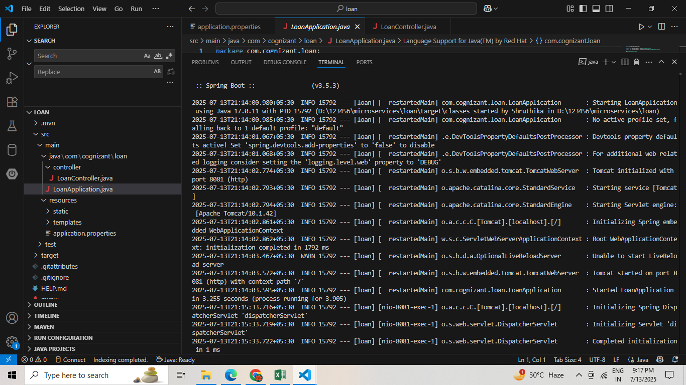

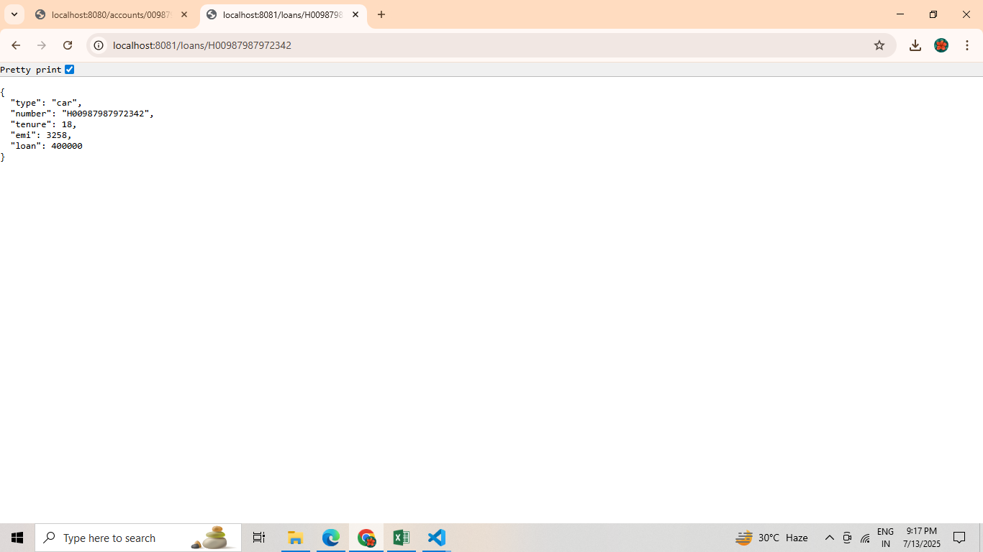

**ADDITIONAL HANDSON**

**Create Eureka Discovery Server and register microservices**

**MY CODE:**

**EurekaServerApplication.java**

package com.example.eurekaserver;

import org.springframework.boot.SpringApplication;

import org.springframework.boot.autoconfigure.SpringBootApplication;

import org.springframework.cloud.netflix.eureka.server.EnableEurekaServer

@SpringBootApplication

@EnableEurekaServer

public class EurekaServerApplication {

public static void main(String[] args) {

SpringApplication.run(EurekaServerApplication.class, args);

}

}

**GreetServiceApplication.java**

package com.example.greet_service;

import org.springframework.boot.SpringApplication;

import org.springframework.boot.autoconfigure.SpringBootApplication;

@SpringBootApplication

public class GreetServiceApplication {

public static void main(String[] args) {

SpringApplication.run(GreetServiceApplication.class, args);

}

}

**NameServiceApplication.java**

package com.example.name_service;

import org.springframework.boot.SpringApplication;

import org.springframework.boot.autoconfigure.SpringBootApplication;

@SpringBootApplication

public class NameServiceApplication {

public static void main(String[] args) {

SpringApplication.run(NameServiceApplication.class, args);

}

}

**ApiGatewayApplication.java**

**package com.example.apigateway;**

import org.springframework.boot.SpringApplication;

import org.springframework.boot.autoconfigure.SpringBootApplication;

import org.springframework.cloud.gateway.discovery.DiscoveryClientRouteDefinitionLocator;

import org.springframework.cloud.gateway.route.RouteLocator;

import org.springframework.cloud.gateway.route.builder.RouteLocatorBuilder;

import org.springframework.cloud.client.discovery.EnableDiscoveryClient;

@SpringBootApplication

@EnableDiscoveryClient

public class ApiGatewayApplication {

public static void main(String[] args) {

SpringApplication.run(ApiGatewayApplication.class, args);

}

}

**ClientApplication.java**

package com.example.clientapp;

import org.springframework.boot.SpringApplication;

import org.springframework.boot.autoconfigure.SpringBootApplication;

import org.springframework.cloud.client.discovery.EnableDiscoveryClient;

import org.springframework.context.annotation.Bean;

import org.springframework.web.client.RestTemplate;

@SpringBootApplication

@EnableDiscoveryClient

public class ClientApplication {

public static void main(String[] args) {

SpringApplication.run(ClientApplication.class, args);

}

@Bean

public RestTemplate restTemplate() {

return new RestTemplate();

}

}

**OUTPUT:**

